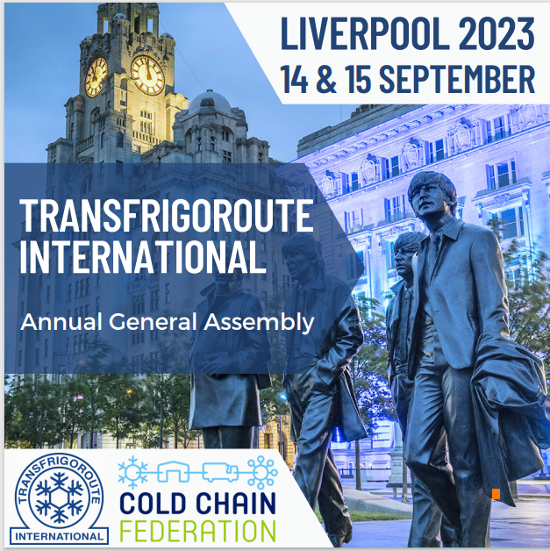
Join us this September for an unforgettable AGM in Liverpool!
We are thrilled to announce that the Transfrigoroute International (TI) Annual General Meeting (AGM) will be held in Liverpool, UK on the 15th of September 2023, in conjunction with the esteemed Cold Chain Live! Event.
TI is invited to join the Cold Chain event on the 14th of September as well as the 15th in the morning. The TI AGM will follow on the 15th in the afternoon, as well as a fabulous dinner on the 15th exclusively for TI members!
Below, you will find the agenda of the CCF event!
Meeting Agenda
DAY ONE – 14th SEPT
09:00 | ARRIVAL COFFEE AND NETWORKING
10:00 | Welcome – Sameena Ali-Khan
10:05 | Paul Bennell - CCF President
10:20 | Data introduction speech (speaker tbc)
10:40 | Clive Thornley – Styne Refrigeration
11:00 | DISCUSSION PANEL (including CCF President, Paul Bennell)
11:20 | Prof Tim Lang - Changing Food Systems
11:45 | COFFEE BREAK / NETWORKING ZONE
12:15 | BREAKOUT SESSION 1
LOGISTICS ZONE |  |  |  | TRANSPORT ZONE |  |  | ENERGY ZONE
Topic on Automation (tbc) |  |  |  | Powering EVs – solving the infrastructure conundrum |  |  | Heat is On – ending energy waste from refrigeration
13:15 | LUNCH AND NETWORKING ZONE
14:15 | BREAKOUT SESSION 2
LOGISTICS ZONE |  |  |  | TRANSPORT ZONE |  |  | ENERGY ZONE
Be the Boss of You… taking control of risk in your business |  |  |  | It’s the Data Stupid – how to unlock the transition to diesel free refrigeration |  |  | …And Freeze – the changing face of blast freezing in cold chain
15:15 | Prof Richard Wilding – Lessons in Supply Chain Resilience
15:35 | Terry Jones – NFU, Food Resilience
15:55 | Session tbc
16:15 | DISCUSSION PANEL (speakers tbc)
16:30 | End of sessions
18:15 | Drinks Reception Sponsored By Magnavale
19:00-22:00 | Street Food Dinner
20:30 | Entertainment / Speaker
DAY TWO- 15th SEPT
09:30 | ARRIVAL COFFEE AND NETWORKING
10:00 | Welcome – Sameena Ali-Khan
10:05 | Sophie-Kim Chapman – VP Sustainability DFDS
10:25 | Scott Tew – Global Head of Sustainability Trane Technologies
10:45 | Andrew Lawrence – Sadel Group / Magnavale
11:05 | DISCUSSION PANEL (speakers tbc)
11:15 | COFFEE – NETWORKING ZONE
11:45 | BREAKOUT SESSION 3
 | LOGISTICS ZONE |  | TRANSPORT ZONE |  |  | ENERGY ZONE
 | Future Border – digital solutions to old problems |  | TI Session on driver shortages |  |  | Right first time – principles for excellence in cold store construction and refurbishment
12:45 | CLOSING SESSION  TI President, Shane, Mike McClendon
13:30 | FINISH
COLD CHAIN LIVE! IS BROUGHT TO YOU BY THE COLD CHAIN FEDERATION IN PARTNERSHIP WITH OUR PLATINUM PARTNERS

15:00-17:00 | TI Annual General Assembly
19:00 | TI Only Dinner Event in Liverpool

Location of the CCF event & the TI AGM

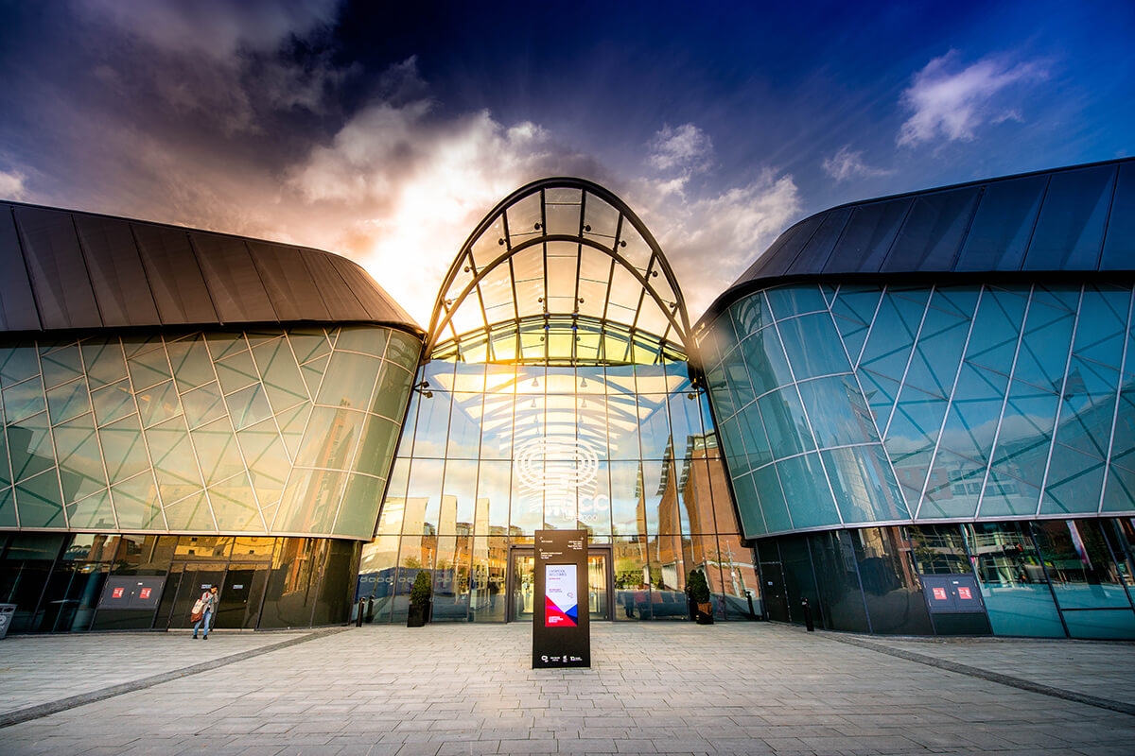
ACC Liverpool

Address:
King's Dock, Port of Liverpool, Kings Dock St Liverpool
L3 4FP
United Kingdom

Suggested Hotels
Cold Chain Federation provides a free accommodation booking service through Liverpool Convention Bureau for convenient access at the ACC Liverpool for the Cold Chain Live! Event. As rooms and rates are guaranteed until 5th September 2023 it is advisable to book accommodation early.
For more information, please visit https://book.passkey.com/go/CCL2023
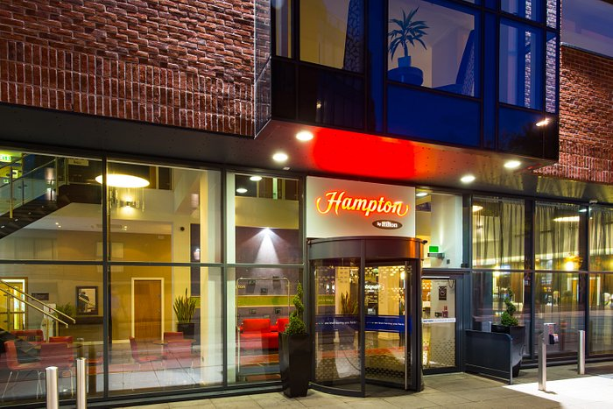
Some suggested options are the following:
- Hampton by Hilton Liverpool City Centre
3-stars hotel, 8.0 rate on Booking.com
Price: £100 per night

Address: Kings Dock Mill / 7 Hurst Street, Liverpool, Merseyside L1 8DA, UK
Location: 9 minutes walking distance from ACC Liverpool

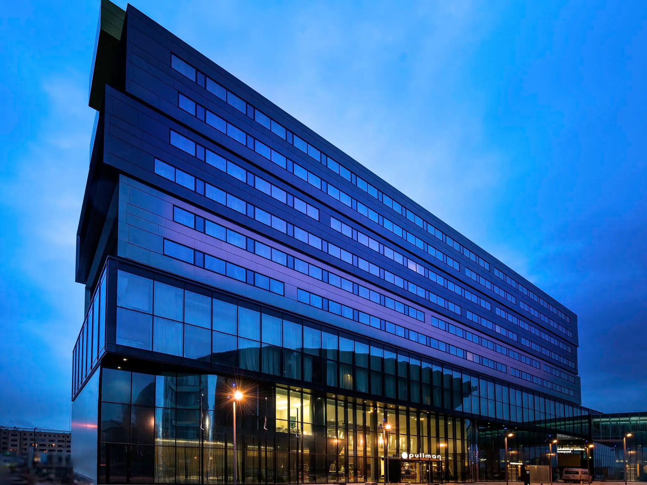
- Pullman Liverpool HQ Hotel
4-stars hotel, 8.9 rate on Booking.com
Price: £173,75 per night
Address: Kings Dock, Liverpool, Merseyside L3 4FP, UK
Location: Pullman Liverpool HQ Hotel is attached to the Arena and Convention Centre Liverpool.
Other hotels’ suggestion from Booking.com:
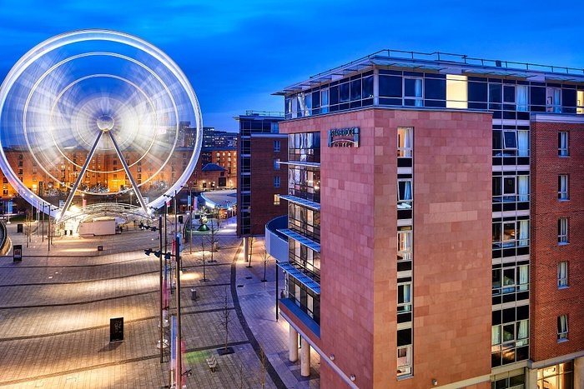
- Staybridge Suites Liverpool, an IHG Hotel
4-stars hotel, 9.1 rate on Booking.com
Price: €138 per night
Address: 21 Keel Wharf, Liverpool, L3 4FN, UK
Location: 3 minutes walking distance from ACC Liverpool

Price
To attend the General Assembly in Liverpool on 14-15 September, the price is of €400 per person. This includes full access to the Cold Chain Federation Live! Event, the TI AGM and dinner on Thursday and Friday.

Sponsorship Opportunities
Please connect with the TI Secretariat member, Monika Patriarchea at monika.patriarchea@grayling.com for sponsorship opportunities.

